Hydrogen Line Telescope

Warren Lee Herrington

Johanna Kay Hein

**Concept of Operations**

FIRST REVISION

30th November 2021

Concept of Operations

for

Hydrogen Line Telescope

Team 10

Approved by:

___________________________

Project Member Date

___________________________

Project Member Date

_____________________________

Prof. Lusher Date

_____________________________

T/A Date

**Change Record**

|  |  |  |  |  |
| --- | --- | --- | --- | --- |
| **Rev.** | **Date** | **Originator** | **Approvals** | **Description** |
| **-** | 9/16/21 | Team 10 |  | Draft Release |
| **1st** | 11/30/21 | Team 10 |  | Final Report 403 – Revision |

Table of Contents

Table of Contents III

List of Figures IV

1. Executive Summary 1

2. Introduction 1

2.1. Background 1

2.2. Overview 2

2.3. Referenced Documents and Standards 3

3. Operating Concept 3

3.1. Scope 3

3.2. Operational Description and Constraints 3

3.3. System Description 4

3.4. Modes of Operations 5

3.5. Users 5

3.6. Support 5

4. Scenarios 6

4.1. 2-Dimensional Selection 6

4.2. Repeated Point Analysis 6

4.3. 2-Dimensional Terrestrial Sweep 6

4.4. 1-Dimensional Terrestrial Sweep 6

5. Analysis 6

5.1. Summary of Proposed Improvements 6

5.2. Disadvantages and Limitations 7

5.3. Alternatives 7

5.4. Impact 7

List of Figures

Figure 1: Hydrogen Line Telescope Block Diagram 2

Figure 2: Helical Antenna Design 4

# Executive Summary

Hydrogen line astronomy is a relatively unexplored and inaccessible aspect of astronomy. Many educators and scientists would benefit from this branch of astronomy if they were given the opportunity to use a reliable hydrogen line telescope. This portion of radio astronomy explores the 1420 MHz spectrum. This spectrum allows for views of the arms of the Milky Way galaxy and glimpses into the wider universe. This wavelength can penetrate many of the gas and dust clouds that block smaller wavelengths used in visual astronomy making hydrogen line telescopes an excellent source of galaxy imaging. This project will allow much more accessibility to educators and scientists by providing a high-fidelity hydrogen line telescope featuring several modes of operation and an intuitive graphical user interface.

# Introduction

The purpose of this document is to introduce the characteristics behind the Hydrogen Line Telescope (HLT) project and discuss a brief history of radio wave telescopes. This type of telescope detects emissions from neutral hydrogen atoms in the Milky Way galaxy. This hydrogen line telescope will feature several modes of operation to give the user flexibility when selecting imaging areas. The telescope will rotate as needed to scan the selected area or point and send a clarified version of the data to an image processing software. This software will create an image of the hydrogen emissions detected by the telescope and output the results as an overlay of the corresponding sky map of that area. The HLT will have an intuitive graphical user interface to make running the telescope and interpreting the results straightforward for educators and researchers.

## Background

Radio astronomy began in the early 1900’s when Karl Jansky discovered that the antenna used for testing a thunderstorm static experiment was also detecting a source of static from outer space. Grote Reber, a radio engineer, later took Jansky’s ideas a step further and created a telescope that could detect a specific frequency of 160 MHz from the sky giving data that showed the location of different celestial objects.1 However, this technique was further narrowed by Hendrik van de Hulst who proposed neutral hydrogen as a reliable source of frequency for radio astronomy. Hulst’s suggestion eventually brought about the hydrogen line telescope which detects frequencies of 1420.406 MHz or a wavelength of 21 cm and was first used in 1951 by Harold Ewen and Edward Purcell.2

The radio waves emitted by neutral hydrogen atoms occur during a rare spin-flip transition.3 Since neutral hydrogen is such a commonly found substance in outer space with concentrations mainly in the Milky Way galaxy, these emissions make this element a good source for frequency detection. Additionally, radio waves can be observed despite obstructions such as cosmic dust, weather, or the atmosphere giving an ideal way of observing the shape of the galaxy. A hydrogen line telescope can also identify Doppler shifts in the detected frequency giving the rotational direction and consequently velocity of the observed celestial object.4

The hydrogen line telescope built during this project will provide several unique features to make it easy for the user to clearly view sections of the galaxy. The user will be able to select an area of emission detection, let the telescope move to retrieve that data, and see the output of the image processing software. This output will show the user where the hydrogen emissions were detected in that area as well as any areas where the software found Doppler shifted frequencies. These results will be shown overlaying a sky map image of the selected area.

## Overview

Figure 1: Hydrogen Line Telescope Block Diagram

*Johanna: GUI, Image & Signal Processing*

*Warren: Route Planning, Antenna & Motorized Mount*

The HLT project will simplify and make hydrogen line astronomy more accessible to researchers and educators. First, using the graphical user interface, a user will select a section of sky to examine with the HLT. The software will then take that selection, account for the rotation of the earth, and plan a route for the antenna to scan that area. The positional instructions are passed to the controller, a Raspberry Pi, which calculates the current angle the mount is at and then tells the linear actuators to move it to the new position. The system takes the voltage induced in the antenna by neutral hydrogen emissions and passes it through a low noise amplifier into the receiver of the antenna. The receiver, a Software Defined Radio (SDR), takes this signal and separates it into its distinct frequencies and magnitudes. The Raspberry Pi takes the data from the SDR and calculates the average frequency from the neutral hydrogen and its magnitude for the subsection of sky the beam is pointed at. The Raspberry Pi constructs a CSV file from this data which is sent via USB back to the software running on the laptop. The software takes this CSV file, calculates Doppler shift, and uses this information to create an image with corresponding color and brightness. This image is finally overlaid onto a sky map and the result is displayed to the user.

## Referenced Documents and Standards

1. [History of Radio Astronomy (upenn.edu)](https://www.sas.upenn.edu/~patann/HistoryRadioAstron.htm)
2. [21-centimeter radiation | Definition, Importance, & Facts | Britannica](https://www.britannica.com/science/21-centimetre-radiation)
3. [Spin-flip Transition | COSMOS (swin.edu.au)](https://astronomy.swin.edu.au/cosmos/S/Spin-flip+Transition)
4. [Hydrogen Line Radio Observations (spaceacademy.net.au)](https://www.spaceacademy.net.au/spacelab/projects/hlineobs/hlineobs.htm)
5. IEEE 802.11 – Local Area Network Technical Standards
6. USB 2.0 – USB 2.0 Specification
7. TIA-568-C.4 – Broadband Coaxial Cabling and Components Standard
8. IEEE 149-1977 – IEEE Standard Test Procedures for Antennas

# Operating Concept

## Scope

The Hydrogen Line Telescope project will enable the user to view neutral hydrogen atom emissions from celestial objects in the galaxy. The HLT will be portable and can be placed in any open area. The mounting system for the HLT can then be leveled automatically during a setup process run through the GUI. The user will be able to select an area of detection through the GUI and instruct the telescope to begin collecting data. The HLT will automatically rotate using positional software and a parallel robot and scan the selected area while feeding the data through a low noise amplifier, signal processing system, and finally an image processing system. The results will give the user a cohesive image of the hydrogen emissions detected in that selected area as well as the direction that each object is moving (towards, static, or away) given the frequency detected. These outputs will be shown overlaying a sky map of the area.

## Operational Description and Constraints

The Hydrogen Line Telescope is designed to be used by more entry level researchers and educators to look at desired sections of the sky. The antenna mounted on a motorized base will make analyzing sections of the sky easy and intuitive.

The constraints from this operational goal are as follows:

* Must be portable by car and two people, this limits the antenna size
* Must be placed on level enough ground to point where necessary.
* Must be robust enough to repeatedly measure the same section of sky and get similar results.
* Must be able to operate fast enough or be able to be left alone for periods of time as to not inconvenience users.

## System Description

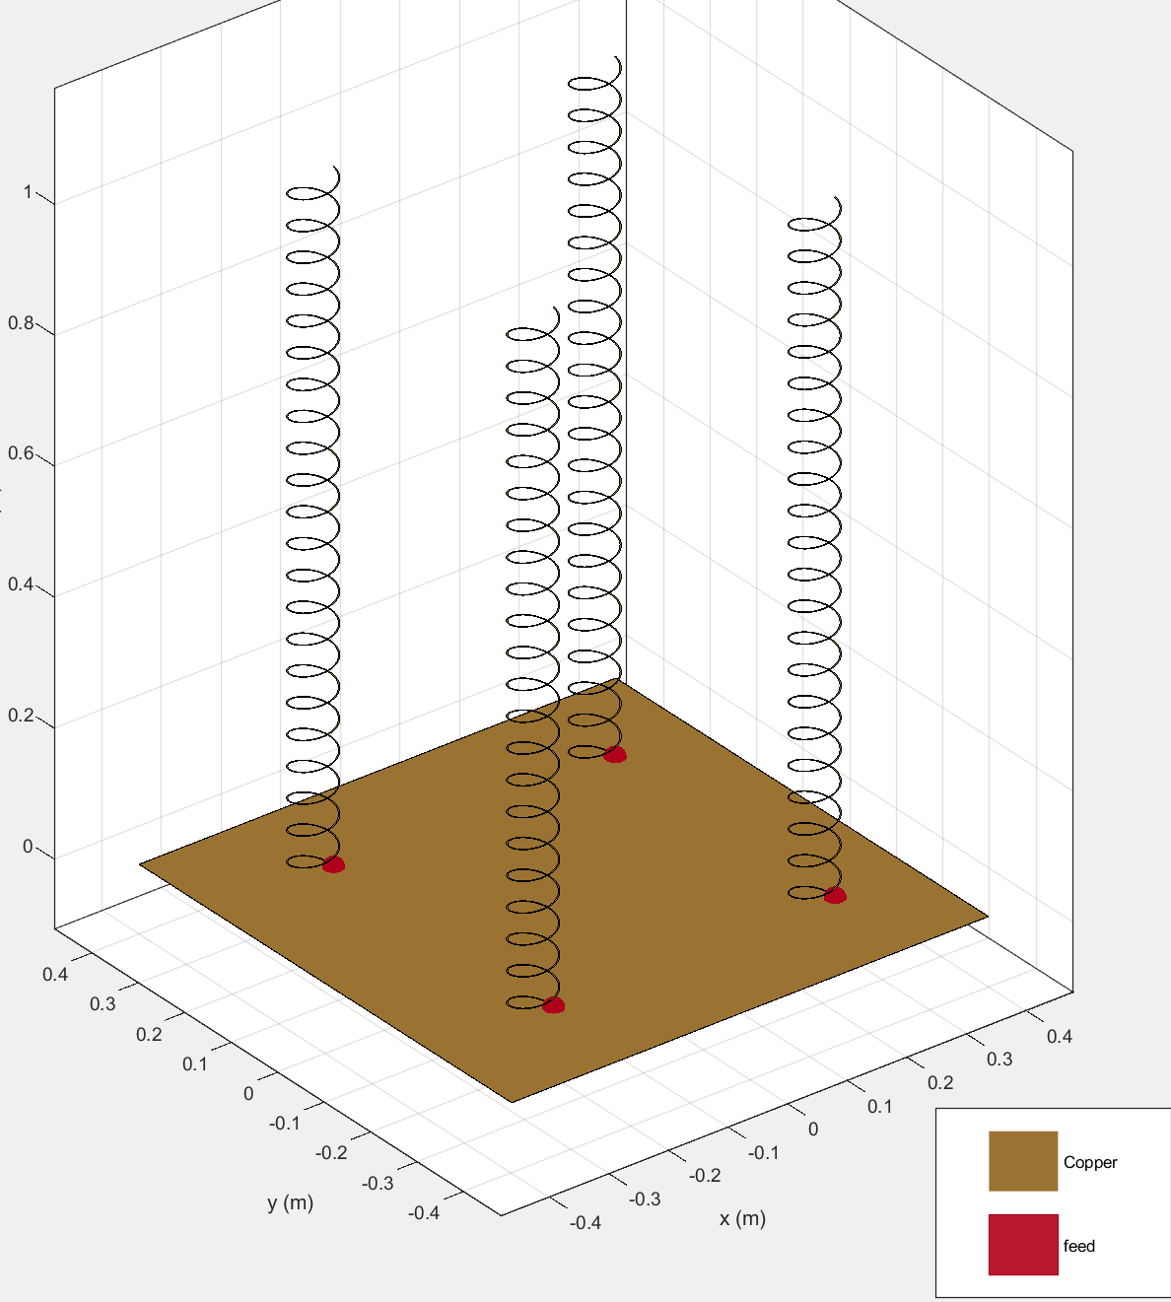

Figure 2: Helical Antenna Design

**Signal Acquisition –** Using a helical antenna array allows the system to have a much denser package while still maintaining a high gain and narrow beamwidth. The helical antenna array is also a robust design that will not be adversely affected during transit or movement in the field (see Figure 2 above). This antenna will output a signal to a Low Noise Amplifier (LNA) that will be positioned as close to the antenna as possible to avoid signal loss. The output of the LNA will then feed into the SDR which will give the signal data to the Raspberry Pi.

**Positioning –** Positioning will be accomplished by linear actuators arranged in a parallel robotic configuration. This will allow for any self-leveling needed as well as the high level of precision needed for accurate positioning and measurements. These linear actuators will be controlled using a relay board and accelerometer to control the position of the mount.

**Image Processing –** This piece of software takes in the data from the Raspberry Pi to calculate the color and intensity of each section of the image based on its Doppler shift and relative magnitude. The image processing software will then overlay data on the corresponding visual image of the night sky and display the combined images as the result.

**Usability –** The intuitive GUI will allow the user to select the section of sky to be scanned. The user can select from four different modes of operation. The HLT will then collect the appropriate data and return the overlaid image to the user.

**Power –** The HLT will be powered by the user’s vehicle power source that will give off the necessary voltages for the stepper motors, controller, and other components.

## Modes of Operations

The HLT project will have four modes of operation that the user will be able to select. The first mode, “2-dimensional selection”, will construct a 2-dimensional image of an area. The user will be able to determine the dimensions of the area in the graphical user interface using a sky map. The second mode of operation will perform “repeated point analysis”. In this mode the user will select one point in the sky and an analysis duration. The telescope will observe that selected point over the duration of the analysis and output a detailed GIF of that point in the galaxy over time. Performing repeated point analysis will give a much more accurate representation of that area in space since different hydrogen atoms will be emitting during different times. The third mode of operation, “2-dimensional terrestrial sweep”, will sweep a section of the sky vertically while the earth rotates. This mode will allow the user to view more area in the sky than they could during the 2-dimensional selection viewing mode. The final mode, “1-dimensional terrestrial sweep”, will simply view a selected point in space while the earth rotates giving a series of detected hydrogen emissions as output.

## Users

This telescope will be used by engineers and researchers to observe the hydrogen emissions of the galaxy for scientific purposes. However, this project will also be simple to run, given the intuitive graphical user interface, meaning that any non-scientific individual could easily run this tool and study the output. This feature makes the HLT a good candidate for use as an educational tool in a classroom setting.

## Support

The resulting hydrogen line telescope will be accompanied by detailed documentation. Some of these documents will cover the technical construction and reasoning behind the different features of this telescope so that the user can fully understand the inner mechanical workings of this project. The HLT will also come with a user manual describing the graphical user interface and the software that connects and controls sections of the telescope and manages data processing. These manuals will also include information about antenna calibration and data results and interpretation to ensure that future users can easily run, collect, understand, and use accurate hydrogen line data of the galaxy.

# Scenarios

## 2-Dimensional Selection

The user would select a box in the sky using the GUI. The HLT would then automatically rotate to gather data from any hydrogen emissions in that area of the sky. Using the data it collected, the HLT would create a 2-dimensional heat map that showed intensity and doppler shift using brightness and color. The software would output this heat map to the user as an overlay of the sky map image of that selected area.

## Repeated Point Analysis

The user would select a single point in the sky. At set intervals the HLT would remeasure the data emitted from that point while tracking it through the sky as long as that point remained in range of the telescope. This data would then be developed and displayed in GIF format to show how the point changed over time.

## 2-Dimensional Terrestrial Sweep

The user would select a point in the sky map. The antenna would then scan a line at this point orthogonal to the earth’s rotation. The antenna collects this data over a user-selected range of time to build a series of heatmaps that the software will overlay over sky map photos and display as a GIF to the user.

## 1-Dimensional Terrestrial Sweep

The user would select a single point in the sky and the antenna would gather data points at specified time intervals as the earth rotates. Over time the data gathered would form a 1-dimensional heat map GIF that would be displayed to the user.

# Analysis

## Summary of Proposed Improvements

The Hydrogen Line Telescope will have several improvements that include:

* Intuitive graphical user interface
* Four imaging modes
  + 2-dimensional selection
  + Repeated point analysis
  + 2-dimensional terrestrial sweep
  + 1-dimensional terrestrial sweep
* Portable power supply and antenna
* Hydrogen line image overlaying a sky map
* Doppler shift analysis

## Disadvantages and Limitations

The Hydrogen Line Telescope may have a few limitations that could include:

* Larger beam width
  + Less precise than telescopes with smaller beam widths
  + Size constraints with this project produce a telescope with a larger beam width
* Frequency range
  + The HLT can only see one frequency range and is not easily customizable for viewing of different wavelengths from the galaxy

## Alternatives

There are some alternatives to the hydrogen line telescope built in this project including:

* The PICTOR telescope - an open-source hydrogen line telescope that can be used to output data and some graphs at a static position for the user
* DIY hydrogen line horn feed telescopes - telescopes that have no specific imaging software to show Doppler shifted frequencies or automated rotational abilities for emission viewing
* Telescopes that detect other frequencies emitted from space - other frequencies that may not be prevalent enough to give accurate images of the galaxy

## Impact

The HLT project involves building a telescope that detects emissions from neutral hydrogen atoms in the atmosphere. These waves, emitting at a frequency of 1420 MHz, provide an accurate method of outer space imaging given the large amount of neutral hydrogen atoms present in the Milky Way galaxy. The telescope built in this project will provide several modes of galaxy imaging through automatic telescope positioning as well as an intuitive graphical user interface. Once complete, this highly scientific project will provide researchers and educators with a reliable, easy to use telescope that will advance hydrogen emission imaging of the galaxy.

As this telescope is simply receiving radio waves, not transmitting waves, this project has minimal to no negative impacts on the environment. This project will take up minimal space, the antenna is projected to take up about one meter cubed of space and can be placed in any open, unused, area such as a rooftop. The HLT project will have a positive impact on society as it will provide a way for interested individuals to view sections of space in order to better understand and appreciate the Milky Way galaxy. This instrument could also be a useful tool for educational purposes. As the waves detected by this telescope are naturally occurring and analysis done on these emissions is purely for scientific appreciation and educational purposes, this project poses no ethical concerns.